433 MHz LoRa Antenna
You have found the antenna made by the 2023-24 Year 10 CanSat team Athena. Here is some helpful stuff about this antenna:

Dimensions & Details
Component | Component Length (mm) | Distance from Reflector (mm) | Distance between previous component (mm)
Reflector (R) | 339 | 0 | N/A
Driven Element/Dipole (D) | 319 | 138 | 138
Director 1 | 292 | 190 | 52
Director 2 | 288 | 315 | 125
Director 3 | 283 | 464 | 149
Director 4 | 279 | 637 | 173
Director 5 | 275 | 831 | 194
Director 6 | 272 | 1039 | 208
Boom Diameter: 20mm
Radiating Component Diameter: 12mm
Frequency f: 433 MHz
Wavelength λ: 692 mm
Element diameter d: 12 mm
Boom diameter D: 20 mm
Total number of elements: 8
Boom length: 1063mm
Gain: 12.7 dBi (approx.)

The antenna should be able to easily send signals for half a kilometre – we tested up to 350 and it worked with careful alignment (we ran out of space in the field to test further) – because the theoretical gain is 12.65 dBi, and a stronger gain means the signal can propagate further. The beamwidth (angle in which signal would be received) should be about 20-30 degrees. The antenna is made of hollow aluminium tubes.

A few tips:
- Use antenna simulation software such as Ansys HFSS – it’s free for students.
- If the beamwidth is too narrow (loses signal if antenna is moved slightly), remove a director.

Parts & Assembly
If you need to print any spare parts, here is a link to them: https://github.com/CanSat-Athena/Diagrams/tree/main/Antenna%20Docs/3D%20Models
For the printed parts, black PLA was used.
The bolts and nuts used are standard M5.
The antenna boom is in two pieces to make it easier to carry, use the joiner part to connect the two. There is also a circular part and a matching hole on the boom with a flat bottom to mount the antenna to a tripod if necessary. When assembled, it should look like this (ignore the coaxial wire coming out of the dipole, the part connecting to the tripod should also have the tripod mounting part described above to mount it to the tripod securely):
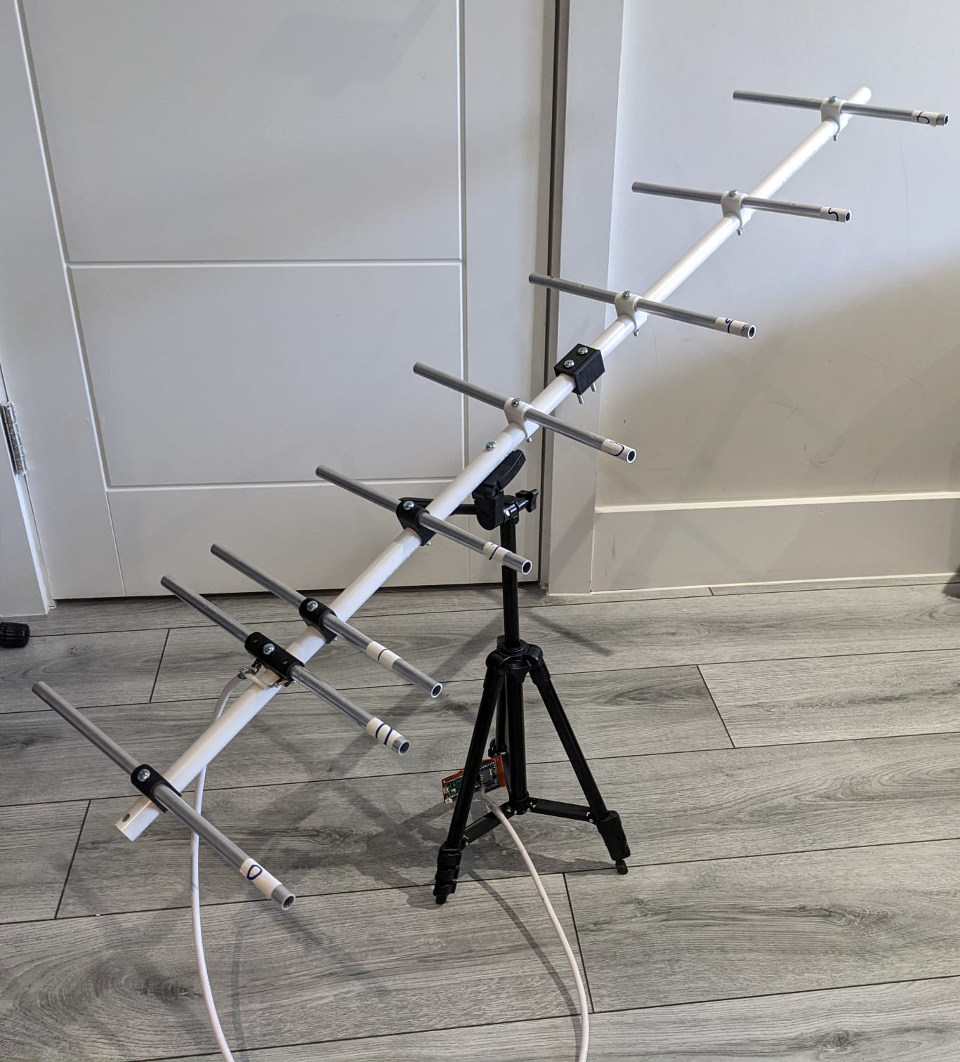

After assembling the antenna, connect the radio to the dipole as such:
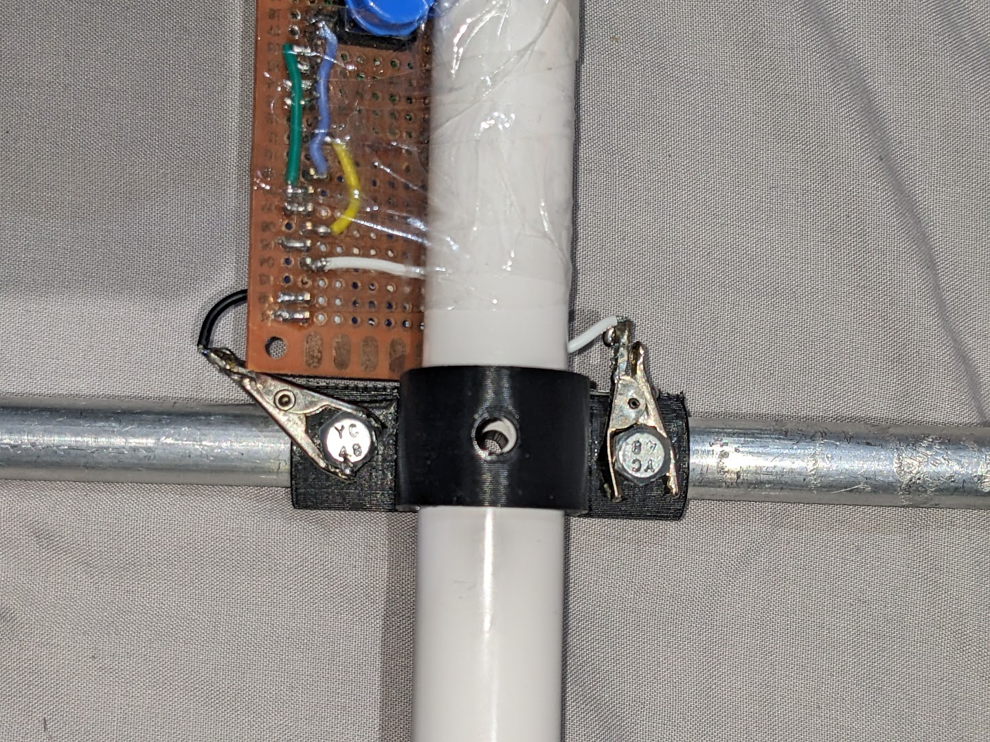

Links
You might find these useful:
Link to the 3D model for both the CanSat and antenna parts on Onshape: https://cad.onshape.com/documents/41446cc90593da251aa18a70/w/317e5d5472789b370bb6c815/e/380754f822a4cc7bc89015d7
Links to our PDR, CDR and FDR: https://github.com/CanSat-Athena/Diagrams/tree/main/Antenna%20Docs
Our code (main code is in CanSat repository): https://github.com/orgs/CanSat-Athena/repositories
Our website (if it is still alive by the time you read this): https://cansatathena.com
Our YouTube channel: https://www.youtube.com/@CanSatAthena
Our Reddit: https://www.reddit.com/user/Project_Athena/
Our Instagram: https://www.instagram.com/athena_cansat/

